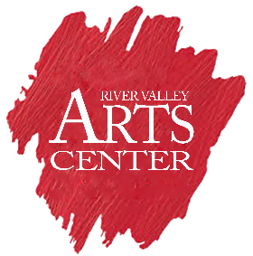

Car Show Entry Form

2nd Annual Car Show Benefitting The River Valley Arts Center

Car Owner: ____________________________________________

Address: ______________________________________________

Vehicle Year: _____________ Vehicle Color: _________________

Make/Model: ___________________________________________

Please Pay the $30 fee on our website at www.rivervalleyartscenter.org or at the gate on
show day.
Our email to email the form to us is rvartscenter@gmail.com and our mailing address is

River Valley Arts Center
PO Box 2112
Russellville, AR 72811

