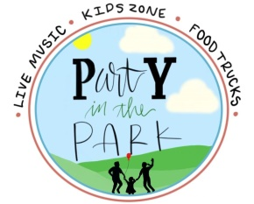
pARTy in the Park

Arts Festival – Saturday April 25, 2020

Rules of Entry for pARTy in the Park

Set up will be from 8:00 am – 9:00 am Saturday, April 25. All booths must be completely set up, staffed and open for business by 10:00 am Saturday,
April 25, 2020. Permission may be granted, upon request, for set up on Friday, April 24, 2020 – but no security will be provided.

Booth placement shall be at the discretion of the steering committee.

All participants are responsible for supplying tables, chairs, etc for their own use. 150 foot extension cords if electricity is requested.

The River Valley Arts Center, Russellville Department of Parks and Recreation, River Valley Prevention Coalition or any employee or committee of
pARTy in the Park will not be held responsible for accidents, thefts or damages occurring on the premises or enroute to or from the premises.

All booths must be accessible to person with disabilities.

Food vendors must submit a menu of what will be served. All food items sold must be in compliance with Arkansas Health Department Regulations.

Arts and crafts are to be handmade or handcrafted; items made from kits are not eligible. No flea market sales.

An accepted application is a commitment to participate.

All booths must be open from 10:00 am until 3:00 pm.
No early breakdowns.

Each vendor must be responsible for removing their booth and cleaning their area immediately following the close of the festival at 3:00 pm. No vendor will be allowed to return later to collect and tear down his or her displays.

Federal Id/tax numbers should appear for all non-profit vendors application forms.

No refund will be issued earlier than 5 days prior to the event.

